UNI T
2
UNIT OUTCOMES
COMPUTER NETWORK

At the end of this unit, learners will be able to:
  - Define what a computer network is.
  - Identify the building blocks of a computer network.
  - Compare and contrast the basic types of networks (LAN, MAN, WAN) and client server vs. peer to peer.
  - Describe the topologies of network.
  - Discuss the advantages and disadvantages of network.
A network is a connection of two or more computers that are linked together in order to share resources(such as printers, files and disks) or allow electronic communications. Using Bluetooth application in your mobile phone to share files is an example of a network. Sometimes, the Internet is called the largest global network.
2.1 Definition of Network
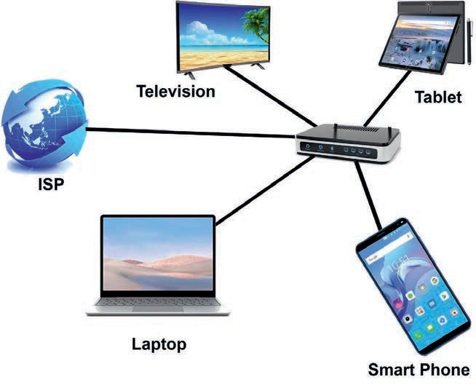
Figure 2.1 Home network

2.2 Fundamental Elements of Network
Networks are comprised of four basic elements: hardware, network software, protocols and connection medium. All data networks are comprised of these four elements, and cannot function without them. The backbone of any network is the hardware that runs it.
Network software is also a foundational element for any network. This type of software helps to manage connected end devices and services the network provides.
Protocols are set of rules to facilitate electronic communication across connected device.
Transmission medium which can be wired or wireless, caries message between end devices.
End devices, which are also called hosts, are devices used to send or receive data over the network. The sending device is called a sender and the receiving one is a receiver. Some examples of end devices are:
  - Computers(such as desktops, laptops, file servers and web servers etc.)
  - Network printers
  - Security cameras
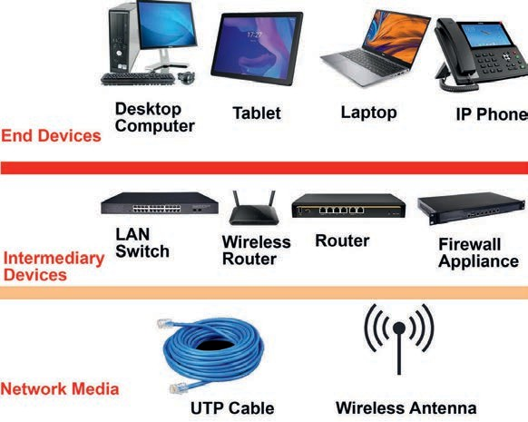
  - Mobile handheld devices.

Figure 2.2 End devices, intermediary devices and media
2.2.2 Intermediary devices
Intermediary devices interconnect end devices. These devices interconnect and work behind the scenes to ensure data flow across the network and the devices. Intermediary devices connect the individual hosts to the network and also can connect multiple individual networks to form an internetwork. Intermediary device includes network cards, routers or network switches, wireless access point (WAP) and repeaters. Without these hardware devices, end devices have no means of accessing a network.

Network Interface Card (NIC)
Network Interface Card (NIC) is a computer hardware component that connects a computer to a computer network.
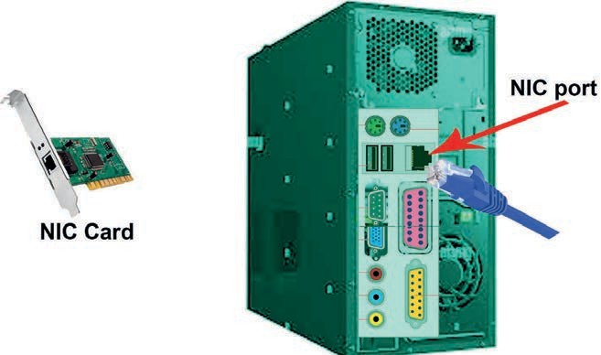
NIC has a slot to plug-in a cable connection with a network.
Figure 2.3: a) Network interface card b) Cable to be plugged in to a desktop computer NIC

Repeater
Repeater enables a network segment to extend the coverage to reach beyond its inherent distance limitation by refreshing or generating the weak network signal.
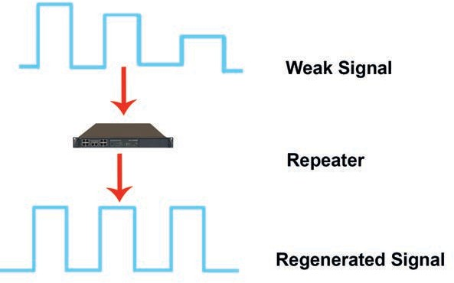
Figure 2.4 Repeater

Switch
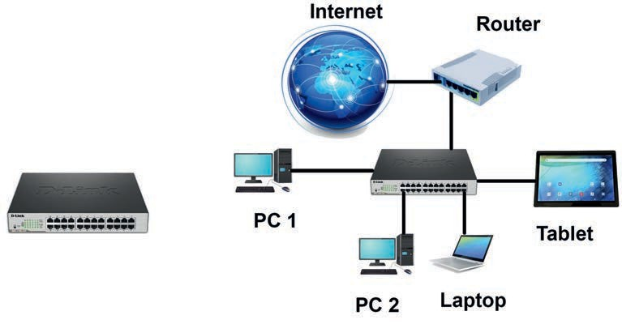
A switch is a networking device that connects multiple devices within a Local Area Network (LAN), enabling them to communicate by exchanging data packets. Switches are more advanced than hubs, as they can filter and forward network packets based on MAC addresses, making them essential for efficient network performance.
In addition, switch forwards packets to specific destination after learning the network topology. To perform this, switch uses a table which contains computer physical address and switch port number on which a computer connected on. A hub is unintelligent device which broadcasts all received packets to all computers connected to it except the sender.

Router
A router is a device that connects two or more packet-switched networks or subnetworks.
A router is such an intelligent device which operates in determination of pathways for electronic messages in networks. The main objective of router is to connect dissimilar and different networks simultaneously. The two switches are connected to each other through the router. Assume two different cases.
Case 1: A computer sends a message for another computer within one network; that is, both the sending and the receiving computers are connected to the same switch.
Case 2: A computer in one network segment sending a message to another
network connected to a different switch.
The router usually works for case 2 type scenario and it selects best route to reach to the destination network. To do this, a router uses a mechanism called routing table, which contains destination network field and interface number of routers.
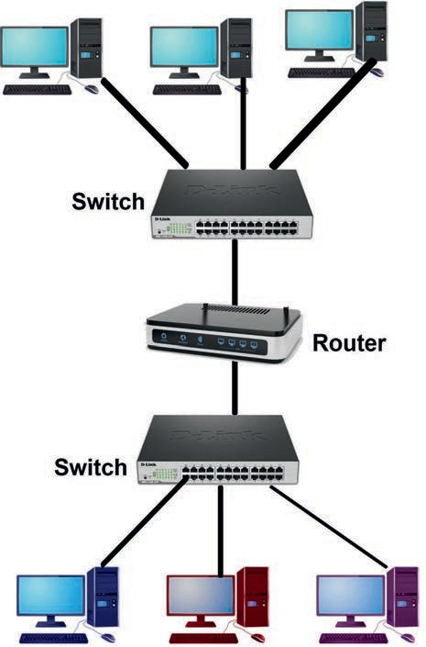

Figure 2.6 Router connecting two networks

Wireless Access Points

A wireless access point (WAP) is an intermediary device in a network that connects various types of wireless communication devices with wireless networks. The connectivity is made possible through Bluetooth and Wi-Fi technologies.
2.2.3 Communication Protocol
In networking, a protocol is a set of rules that governs data communications. In order for different network hardware to interact with the network, they should follow the same rules called protocols. It is software that instructs network devices on how to connect to the network and how to interact with one another. Internet Protocol (IP) is one of the important communication protocols and used for addressing network devices and forwarding data from one network to another.
2.2.4 Connection Media

Without physical connections(wired or wireless), a network cannot function. The connection media are the media which are used to carry the message from sender to receiver. We have two types of communication medium: wired and wireless.
  - Wired medium: It is also called guided medium. It is a cable that connects end devices. Copper and fiber optic cables are examples of wired medium. The most common copper cable used in networks today is unshielded twisted-pair cable (UTP), which uses electric signal to transmit message for a maximum distance of 100 meters. Fiber optic cable uses light to transmit signal at faster speed and longer distance than copper cable.
  - Wireless Medium: It is also referred to as unguided media or unbounded transmission media. It is used to communicate information through the air, water or vacuum, e.g. radio Waves, micro waves, infrared waves and satellite communications.

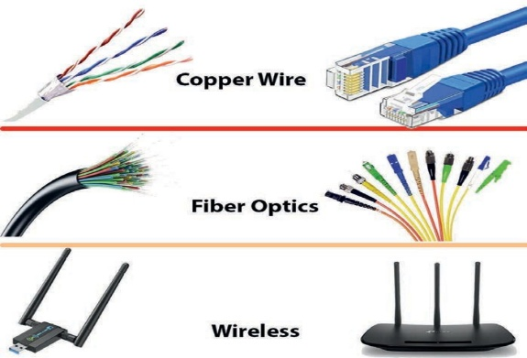
Figure 2.7 Types of communication medium

2.3 Types of Networks
There are different types of network classified based on the following four categories:
- Network media
- Size of the network or geographical coverage of the network
- Topology
- Resource security and access
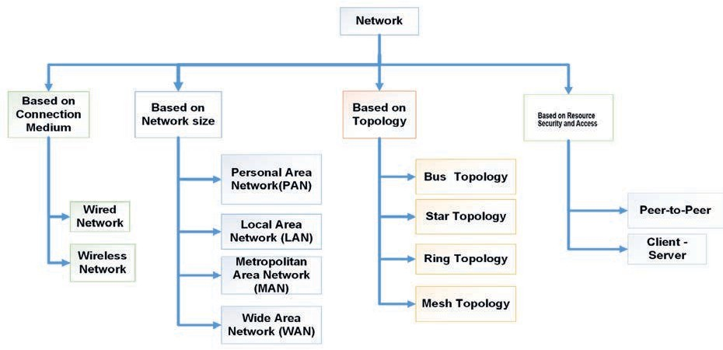
2.3.1 Types of Network Based on Connection Medium

Based on connection medium, computer networks are classified into two
- wired and 2. wireless networks.

Wired Network
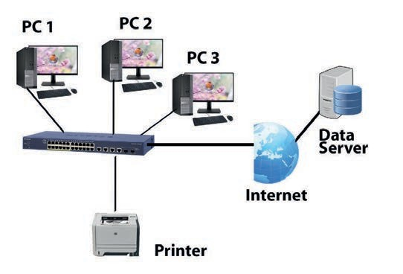
Wired networks, also called Ethernet networks, are the most common type of local area network (LAN) technology.

Wireless Network
Wireless networks have no physical connection with the wired network; instead they get connected through the wireless access point (WAP). A wireless network, which uses high-frequency radio waves rather than wires to communicate between nodes, is another option for home or business networking.

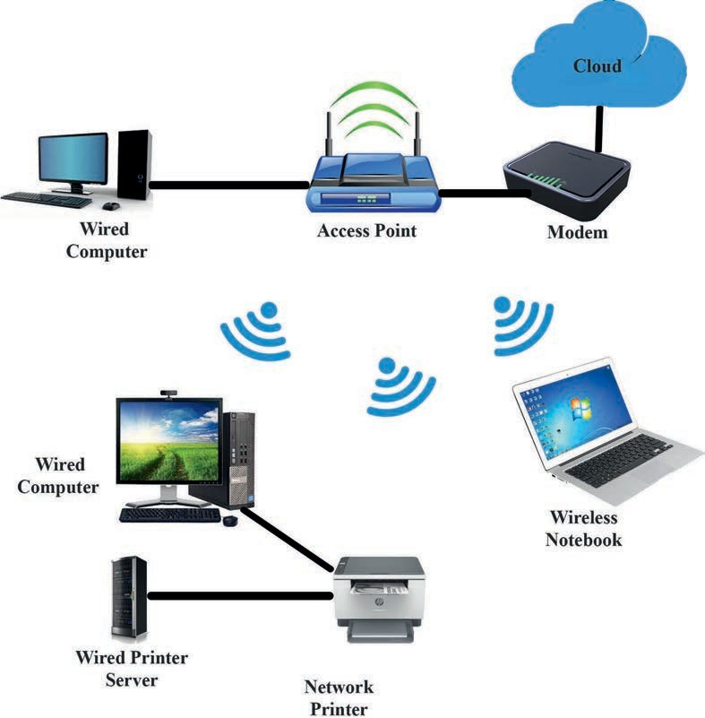
2.3.2 Types of Networks Based on Size

Computer networks can be classified according to their size, which depends on the geographic area they cover and the number of connected devices. Networks may range from small setups within a single room to global connections involving millions of computers.
The main types of networks based on size are:
- Personal Area Network (PAN): The smallest network, designed for a single person’s devices (e.g., Bluetooth connections). It have 1M-10M. e.g Room ,Building
- Local Area Network (LAN): Covers a limited area such 1M-100M-1KM as a home, office, or school.
- Metropolitan Area Network (MAN): Spans a city or large campus, connecting multiple LANs at 10Km .
- Wide Area Network (WAN): The largest type, connecting devices and networks over 100KM-10,000KM distances, even globally (e.g., the Internet).

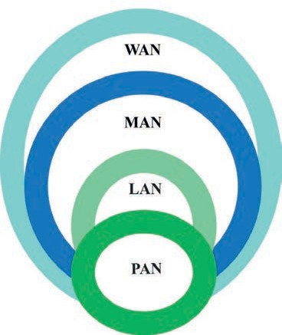

2.3.3 Types of Network Based on Topologies

Network topology defines how various computers or electronic devices represented as nodes are connected to one another in the network.
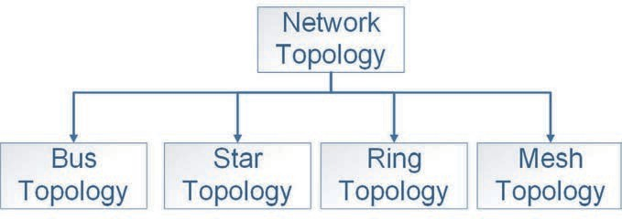

Bus Topology
In bus topology, there is a long cable called bus which acts as a backbone for all the nodes. A bus topology network connects each computer or electronic devised to a backbone cable (or bus) just like a water pipe interconnections.
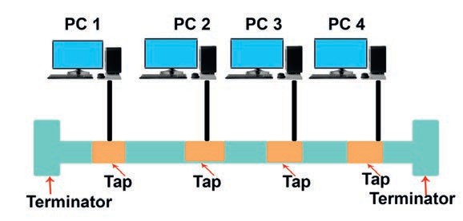

Figure 2.17 Bus topology
A bus is easy to install and uses less cables than other topologies,
A bus topo. is that, even if a portion of the bus breaks down, the whole bus cannot function.

Mesh Topology
In mesh topology (also called complete topology), each node is connected to every other node by direct links
This topology has the advantage in terms of data security. It is also robust; that means, if one link is down, the rest of the network can still continue.
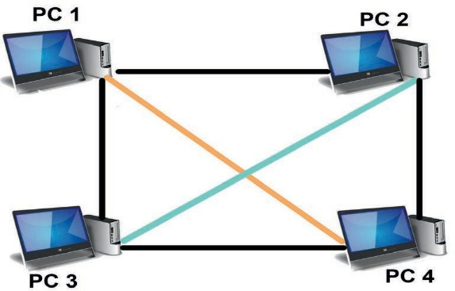

Star Topology
In a star topology, each device has a dedicated point-to-point link only to a central controller, usually called a switch. The devices are not directly linked to one another. Unlike a mesh topology, a star topology does not allow direct traffic between devices,
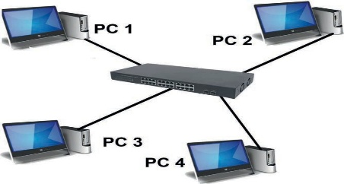
Star topology is cheaper than mesh topology. It is also relatively easier to install, maintain and reconfigure

Ring Topology
In ring topology, each node is directly connected to only its two adjacent neighbors. If a node wants to send something to a distant node on a ring, it has to go through many intermediate nodes, which act like repeaters, reproducing the incoming bit stream with full signals on the outgoing line.
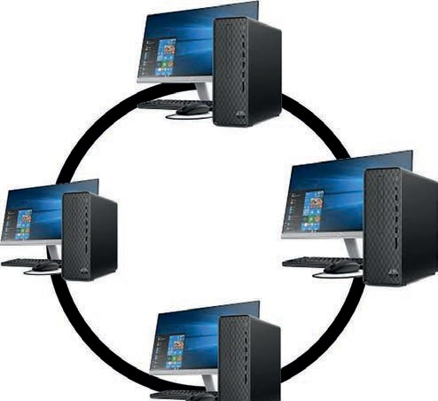
A ring is easy to reconfigure and install. In a ring, a signal normally circulates all the time. A node not receiving any signal for a long time indicates a fault. Therefore, fault isolation is relatively easy in a ring.
Topology | Advantages | Disadvantages
Bus | - Cheap  - Easy to install | - Difficult to reconfigure  - Break in bus disables entire net work
Star | - Cheap  - Easy to install  - Easy to reconfigure  - Fault tolerant | - More expensive than bus
Ring | - Efficient  - Easy to install | - Reconfiguration is difficult  - Very expensive
Mesh | - Simplest  - Most fault tolerant | - Extremely difficult for reconfigure- ration  - Extremely expensive  - Very complex

2.3.4 Types of Network Based on Resource Security and Access
Peer-to-Peer Network In a Peer-to-Peer network, each machine (computer) is known as peer and can participate in the sharing of files or resources. No server is required in this network, so there is no additional cost for a dedicated machine, but there is also no a real security.
A peer-to-peer network is also called workgroup and there is no hierarchy among the computers. This mean that all computers are peers (equals) and the connection is created for resource sharing and communication purposes only. The number of computers in peer-to-peer network usually does not exceed 10.
Advantages of peer-to-peer network
- Server is not required.
- All computers are equal in the network.
Disadvantages of peer-to-peer network
- Provides share level security, i.e. it applies a trust-based security.
- Can work in small environments only.
Client-server Network A client-server network involves multiple clients or workstations, connecting to at least one central server. Most resources are installed on the server. When clients need access to these resources, they access them from the server.
Table 2.3 Comparison of client-server and peer-to-Peer networks

S.No | Client-server Network | Peer-to-peer Network
1 | Clients and server are differentiated; specific server and clients are present. | Clients and server are not differentiated.
2 | Focuses on information sharing. | Focuses on connectivity.
3 | Centralized server is used to store the data. | Each peer has its own data.
4 | Server responds the service which is requested by client. | Each and every node can do both request and respond for the services.
5 | Costlier than peer-to-peer network. | Less costly than client-server network.
6 | More stable than peer-to-peer net-work. | Less stable if number of peer is increased.

2.4 Advantages and Disadvantages of Network
2.4.1 Advantages of network
There are more advantages to a network than disadvantages. In fact, many companies today would not exist without accessing some form of network.
- Sharing data and information
- Communication .
Communication at a distant is called telecommunication; ‘tele’ in Greece is to mean remote.

- Sharing hardware – Expensive hardware devices connected to a network can be shared among all users.
- Storage devices such as Hard Disk that are shared on a storage server, which is also called NAS (Network attached storage), can store and access vast amounts of information.
  - A printer which is attached and shared on a server (printer server) allows all network users to print from one printer according to their privilege configured on the server by a network administrator.
  - Fax machines, Scanners, more powerful computers, such as super computers that can perform complex tasks within short period of time than a single computer will take to complete.
  - Share software – Different application software and Internet-based services can be shared over the network for all licensed users for the software. For instance, we can share software such as computer games and work Internet-based services such as e-learning. E-learning or learning management system in its broadest sense is designed to support teaching and learning as well as student-to-student and student-to- teacher instructions.
- Transferring money - Being connected to a secure network allows a person or business to digitally transfer money between banks and users.
2.4.2 Disadvantages of network
- Virus and malware - Networks make sharing information between network users easy. Unfortunately, this also means that viruses and other malwares have an easier time spreading between computers on a network.
- Vulnerabilities - When computer are connected on the network, it will be accessible remotely, with these potential new methods of accessing the computer.
- Complex - Networks are complex, and setting up and managing a network for a business or corporation requires someone with a lot of experience or certification.
- Cost - Setting up, managing and administering a network hardware and software incurs cost to the organization building a network.
- Social media effect on youth and adults - particularly youths, including students, waste their time on use of social media and unsafe Internet resources.

UNI T
3
UNIT OUTCOMES
APPLICATION SOFT WA RE

